Clinical Skills Competency Assessment

Insulin Administration

Registered Nurse Name:
Registered Nurse Signature:
Assessor Name:
Assessor Signature:
Pass/Fail:

Date Competency completed:

WE STATEMENT

We focus on continuous learning, innovation and improvement across our organisation and the local system. We encourage creative ways of delivering equality of experience, outcome and quality of life for people. We actively contribute to safe, effective practice and research.

INTRODUCTION

The Insulin Administration Competency has been designed to assess staff awareness and confirm the safe administration of insulin.

Diabetes UK (2016) discussed how as the population ages, the number of older people with diabetes is rising rapidly. Many of those diagnosed with diabetes have other conditions that make self-management complex, such as dementia, arthritis and tremors. As a result, an increasing number of people with diabetes rely on community care providers, such as our care homes, to administer their insulin injections for them.

This competency is used within Elizabeth Finn to ensure that residents, within our care, whom are diagnosed with diabetes are given their prescribed insulin injections at the right time, in the right amount and in the right way.

The Nursing and Midwifery Council code of conduct (2019) highlights that to be accountable for the decision to delegate, the registered nurse must:

- Only delegate tasks and duties that are within the other person’s scope of competence, making sure that they fully understand instructions;
- Make sure that everyone they delegate tasks to is adequately supported to provide safe and compassionate care; and,
- Confirm that the outcome of any task they have delegated to someone else meets the required standard.

The non-registered practitioner is responsible for their own decisions and actions. For the non-registered practitioner to be accountable for their decisions and actions, they must:

- Have the knowledge and skills to perform the activity or intervention;
- Accept responsibility for the activity; and,
- Have the authority to perform the activity within their role, through delegation and the policies and protocols of the organisation.

PRE COMPETENCY WORKBOOK

What is blood sugar/glucose?

Blood sugar, also known as blood glucose, is the body’s main energy source. The bloodstream carries glucose to all of the cells in the body, allowing it to function correctly. Blood glucose measurements represent how much sugar is being transported in the bloodstream at the time of the measurement.

The word glucose is derived from the Greek word meaning 'sweet'. Glucose, found in carbohydrate-rich foods such as potatoes, fruit and bread, travels down the oesophagus and to the stomach. Once food is in the stomach, enzymes and acids will break it down into small pieces. Glucose will be absorbed from the small intestine into the bloodstream in order for it to be transported throughout the body.
Blood sugar levels fluctuate throughout the day, rising after someone has eaten and then settling again after an hour or so. These levels are their lowest before the first meal of the day, which is typically breakfast.

How does the body control blood sugar?

When the blood sugar levels rise, as they do after eating a meal, the pancreas releases insulin. Insulin enters the bloodstream in order to ensure that the sugar from food is transported by the blood to the cells where it is required, and transformed into energy that allows the body to function.

Insulin travels to different target cells within the liver and muscle tissues of the body, causing glucose to be absorbed and used for energy. In the liver it is converted into glycogen. Glycogen is a readily mobilised form of stored glucose when the body needs it.

If blood glucose levels reach a low level when someone hasn’t eaten for some time and no nutrients from the last meal remain in circulation in the body, then the pancreas will produce a different hormone known as glucagon. This hormone will cause the liver to convert the stored glycogen back into glucose and release this into the blood. Thus, bringing blood sugar levels back to normal.

Insulin, glycogen and glucagon levels will continually rise and fall in order to regulate blood sugar levels.

Diabetes is a chronic disorder that, if not treated and managed carefully, can result in severe health complications that include blindness, heart disease and even lower-extremity amputations.

If someone suffers from type 1 diabetes then the immune system will destroy the cells that release insulin, eventually eliminating the production of this vital hormone in the body. If the body does not produce insulin, then cells are unable to absorb the sugar needed for energy.

Suffering from type 2 diabetes means that the body is unable to use the insulin it produces efficiently, insulin resistance is the early onset of Type 2 Diabetes. The fat, liver and muscle cells of the body are unable to absorb and store glucose leading to a build-up in the blood known as hyperglycaemia which impairs a variety of bodily functions.

Blood Sugar Testing

NICE recommends that if someone has a diagnosis of Type 1 diabetes, their blood sugar should be tested no less than four times a day, this includes before every meal and going to bed.

If someone is prescribed a medication that may increase your risk of hypoglycaemia, then your blood sugar levels should be tested regularly.

Target blood sugar levels

Your blood sugar levels are given to you as a unit of measurement written as either 'mmol/l' or 'mmol/litre'. In order for your risk of any long-term health issues due to uncontrolled fluctuations of your blood sugar levels to be minimised, your doctor will advise you to aim for the below target levels:

• Before breakfast = Your fasting level should be between 5 and 7 mmol/litre
• Before other meals during the day = Your level should be between 4 and 7 mmol/litre

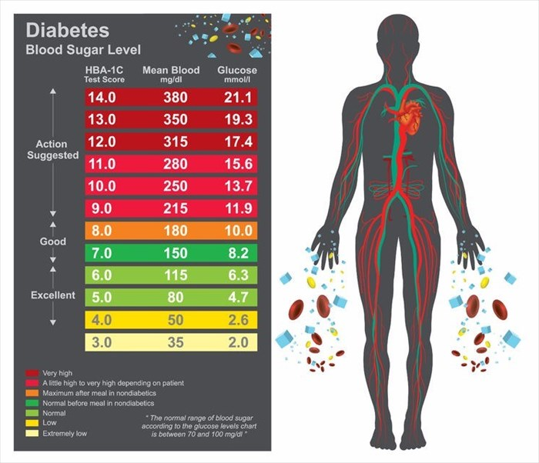

What is high blood sugar (hyperglycaemia)
If your blood sugar levels are chronically higher than normal, then this is referred to as hyperglycaemia. This is a common issue for those suffering from diabetes. The condition can also affect pregnant women who have gestational diabetes and occasionally those who are severely ill (i.e. have suffered a stroke, heart attack or severe infection).
Some of the symptoms of hyperglycaemia include:
- Increased thirst
- Hunger
- Frequent urination
- Headaches
- Fatigue
- Blurred vision
- Issues with concentration and/or thinking
If severe hyperglycaemia is left untreated the condition can lead to organ and tissue damage as the excess glucose present in the body can make it difficult for the organs and cells to function correctly. The disorder can also impair the immune system response in the healing of wounds and cuts.
Other severe symptoms of hyperglycaemia include:
- Nerve damage
- Visual issues
- Kidney damage
- Blood vessel damage
Mild hyperglycaemia, depending on the cause, will not typically require medical treatment. Most people with this condition can lower their blood sugar levels sufficiently through dietary and lifestyle changes.
Those with type 1 diabetes will require the administration of insulin (usually via injection), while those with type 2 diabetes will often use a combination of injectable and oral medications (anti-diabetic medications), although some may also require insulin.
What is low blood sugar (hypoglycaemia)?
Hypoglycaemia is a condition wherein blood sugar levels are too low. This condition affects a number of diabetic people when their bodies do not have enough glucose to use as energy. Hypoglycaemia is commonly the result of taking too much of the medication/s prescribed to treat diabetes, eating less than expected, exercising more than normal or skipping meals.
Some of the symptoms of hypoglycaemia include:
- A pale face
- Unexplained fatigue
- Hunger
- Excessive perspiration
- Skin tingling
- Headache
- Trembling in hands and other body parts
- Blurry vision
- Rapid heart rate
The key to treating low blood sugar is to eat something rich in carbohydrates such as a granola bar, fruit, fruit juice or cookies if you begin to show any of the above-mentioned symptoms. Those who have low blood sugar are often aware of this and will tend to carry something to eat on them in case of a hyperglycaemic episode.
Further information can be found on the following links:
https://www.diabetes.org.uk/
https://www.mymed.com/search/diabetes-type-1
https://www.mymed.com/search/diabetes-type-2
https://www.mymed.com/search/diabetes-diabetes-mellitus
Competency
Competency | Comments | Pass | Fail | Employee’s  Signature | Assessor’s Signature
Diabetes Knowledge
Explain and demonstrate an awareness of what a normal blood sugar reading should be (4 – 7mmol).
Explain where a resident’s BM should be recorded on EMAR/iCare.
Demonstrate an awareness of Type 2 Diabetes and its treatment.
Demonstrate an awareness of Type 1 Diabetes and its treatment.
Explain what is meant by the term hypoglycaemia.

Explain what is meant by the term hyperglycaemia.

Explain what to do in the event of a Hyper or Hypoglycaemic event.
Explain how mental health issues, such as dementia, depression and anxiety may affect people with diabetes.
Explain the effect acute ill health, such as an infection may affect people with diabetes.
Identify the effects of food and medication have on blood glucose levels and how this will affect the patient.
Explain the relevance and reasons for accurate blood glucose testing and recording.
Identify how often you would record a resident’s blood glucose monitoring.
Explain how you would identify is a blood glucose monitoring machine is safe to use. (Check for recalibration date.)
Explain the importance of accurate care planning in relation to diabetes.
Insulin Knowledge
Explain why insulin is given and its effects on blood glucose levels.
Explain the importance of timely administration of insulin and the implications if insulin not administered at prescribed time.
Explain how to add a split dose to EMAR – ensuring that all prescriptions over
50 units can still be administered safely.
Explain the importance of safe storage of insulin, either in the fridge or in the drug trolley and why.
Insulin Administration
Identify the location of the company policy in relation to medication administration.
Explain the importance of an initial visual and verbal assessment of the resident, prior to admisntration of insulin.
Explain the importance of gaining the resident’s consent, prior to administering insulin.
Identify how consent would be gained, in the event of a resident with fluctuating or poor capacity.
Explain the correct safety checks to be carried out prior to administration. (The Six Rights).
Explain the importance of cross referencing EMAR and the medication label to ensue correct admisntration guidance if followed.
Identify suitable sites for insulin administration and show an understanding of the importance of site rotation.
Explain how often you would inspect administration sites for signs of lipohypertrophy.
Explain the importance of accurate and documentation and record keeping.
Identify who you would contact for further specialist advice, if required.
Explain the safe disposal of sharps, following the administration of insulin
(ensure that sharps bins are dated and signed when opened and sealed).
In the event of a needle stick injury, explain where you would locate the needle stick injury flowchart.

Competency complete.

