Clinical Skills Competency Assessment

Clinical Observations
HCA’s Signature

Registered Nurse / Carer Name:
Registered Nurse / Carer Signature:
Assessor Name:
Assessor Signature:
Pass / Fail:

Date Competency completed:

WE STATEMENT

We focus on continuous learning, innovation and improvement across our organisation and the local system. We encourage creative ways of delivering equality of experience, outcome and quality of life for people. We actively contribute to safe, effective practice and research.

INTRODUCTION

This competency has been designed to promote the safe and effective use of equipment and associated skills and knowledge for the individual to understand the reasons why resident clinical observations are taken;

On completion of the competency the person should be able to:

- recognise the limitations of their individual roles and responsibilities as part of taking, recording and reporting clinical observations
- identify the equipment required to record clinical observations
- be able to correctly use equipment used to record resident observations in practice
- understand why clinical observations should be accurately recorded (in line with statutory and professional requirements for accurate record keeping)
- identify the normal and abnormal parameters for routine resident observations
- have an awareness of when and how to escalate concerns regarding out of range resident observations
- be aware of the responsibilities regarding the management of a deteriorating resident
- An awareness of documents that are used in various NHS hospitals and other health and social care settings
- Be able to accurately use the NEWS2 observation document and escalate action and handover a resident to an emergency healthcare practitioner

The competency should be completed by each Registered Nurse or carer who has a responsibility to undertake the clinical observations of a resident.

A Registered Nurse (s) must be allocated with the assigned responsibility for the use of this competency assessment with other Registered Nurses and Care staff where appropriate to demonstrate efficiency and competency of the measurement of clinical observations.

The Registered Nurse should have confidence in his/her actions performing this activity satisfactorily without supervision and/or assistance displaying high quality of work with understanding and appropriate application (Benner 1984). The NMC Code of Conduct should be adhered to, to ensure the Registered Nurse understands his/her responsibilities with regards to the measurement, recording and monitoring of clinical observations.

Competency & Awareness | Comments | Pass | Fail | RN / CA Signature | Assessor’s Signature
Discuss the policy for NEWS2 and Clinical Observations
Identify and describe own processional accountability (NMC code of conduct).
Equipment required for clinical observations
Be able to state what equipment or information is needed to take to a resident’s room to measure:
- Blood Pressure
- Pulse
- Temperature
- Respirations
- Level of consciousness

Be able to locate the homes storage of equipment for the recording of a resident’s clinical observations
Preparation
Demonstration of hand hygiene prior to the measurement of observations
Demonstration of the cleaning of equipment used for measurement of observations
Demonstrate how to introduce to the resident the process for the measurement of observations
Demonstrate confirmation of the resident’s name
Demonstrate the confirmation of the resident on a handheld device (MPOC)
Demonstrate the access of the NEWS2 chart on the resident’s record
Demonstrate the access to the clinical prompt information for NEWS2
Heart Rate – Pulse (HR)
Demonstrate how to palpate the resident’s radial pulse, located at the radial side of the wrist, with the tips of your index and middle fingers aligned longitudinally over the course of the artery.
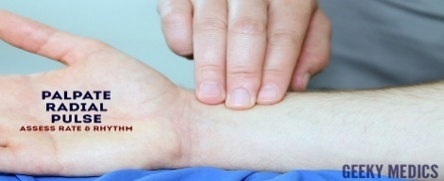
Demonstrate the rate and rhythm of the radial pulse.
Demonstrate for how long the pulse rate should be measured.
Demonstrate what action to take if the pulse rate is irregular
Discuss why a pulse rate may be irregular
Discuss what is a normal heart rate
Discuss what the term bradycardia means and what heart rate would indicate this?
Discuss what conditions may be associated with bradycardia
Discuss what observations may the resident be displaying with Bradycardia?
Discuss what may cause bradycardia
Discuss the term tachycardia and what heart would indicate this?
Discuss what observations may the resident be displaying with tachycardia?
Discuss what may cause tachycardia?
Discuss the action to be taken if the pulse rate does not appear normal for the resident
Discuss how to record this on the NEWS2 chart
Discuss the action to be taken if the heart rate is outside of the normal range or you are unable to record a pulse rate accurately?
Respiratory Rate (RR)
Demonstrate how to observe a resident’s respiratory rate
Discuss why you observe respiratory rate while still palpating the radial pulse.
Discuss how long you would record the respiratory rate
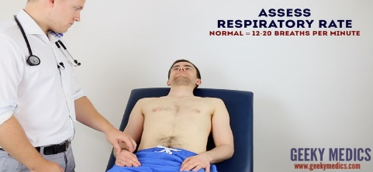
Discuss what is a normal respiratory rate
Discuss the term bradypnea and what respiratory rate would this be recorded
Discuss the term tachypnoea and what respiratory rate would this be recorded
Discuss what respiratory conditions may alter the respiratory rate
Demonstrate how to record respiratory rate on a NEWS2 chart
Discuss the action to be taken if the respiration rate is outside of the normal range or you are unable to record respirations
Oxygen Saturation Sp02
Discuss the use of a Pulse Oximeter:
Infection control
Preparation of the resident’s finger
When not to use a pulse oximeter
Demonstrate how to select an appropriate site
Demonstrate how to switch on pulse oximeter and show that it is in working order
Demonstrate the procedure for obtaining a reading
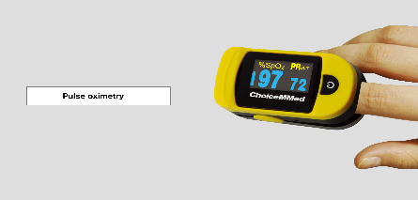
Demonstrate how to record the reading on a NEWS2 chart
Target oxygen saturation
NEWS2 has two different scales for recording oxygen saturation:
Scale 1 has a target oxygen saturation of ≥ 96% and is used for most patients.
Scale 2 has a target oxygen saturation of 88 – 92% and is used for patients at risk of hypercapnic respiratory failure (e.g. patients with COPD).
Discuss the understanding of this difference when recording observation on NEWS2 chart
Discuss the action to be taken if the Recording of SPO2 is outside of the normal range or unrecordable?
Blood Pressure (BP)
EFHL Homes have access to digital blood pressure monitors these will differ therefore use should be according to the manufacturer’s guidelines
Demonstrate the position of the blood pressure cuff so that it aligns with marker for the brachial artery.
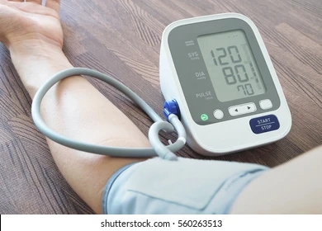
Discuss the basic definition of blood pressure
Discuss the use of the systolic reading of Blood pressure for the NEWS2 chart
Discuss the normal Blood pressure range for a resident
Discuss what is Hypotension and what may be the causes of this?
Discuss Hypertension and what may be the causes of this?
Discuss the action to be taken if the Blood pressure is outside of a normal range or unrecordable.
Temperature
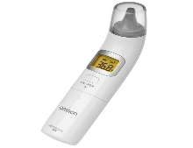
EFHL Homes have access to digital tympanic Thermometers these will differ, therefore use should be according to the manufacturer’s guidelines
Demonstrate the setup of the digital thermometer.
Demonstrate the correct insertion into the auditory canal for the purpose of recording the tympanic temperature
Discuss the normal range of a tympanic temperature for a resident
Discuss what would constitute a raised temperature range (pyrexia)
Discuss what action is required if a raised temperature is recorded
Discuss how to record the temperature on a NEWS2 chart
Discuss action to be taken if a temperature is outside of the normal range or unrecordable.
Documentation
Discuss the use of the NEWS2 Chart on ICARE
Demonstrate the access of the chart, recording of observations and how to escalate any action required.
Discuss the use of the SBAR tool for the clinical handover of a deteriorating / unwell resident
Discuss the signs of Sepsis you may observe in a resident
Discuss the action you would take to escalate your concerns

Competency Complete.

