Care Staff (Non – Registered)
Clinical Skills Competency Assessment

Skin Integrity and Pressure Ulcer prevention

Care Assistant Name:
Care Assistant Signature:
Assessor Name:
Assessor Signature:
Pass / Fail:

Date Competency completed:

WE STATEMENT

We focus on continuous learning, innovation and improvement across our organisation and the local system. We encourage creative ways of delivering equality of experience, outcome and quality of life for people. We actively contribute to safe, effective practice and research.

INTRODUCTION

This competency has been designed to assess staff knowledge and skills in identifying and managing residents who may be deemed to be at risk of altered skin integrity and at risk of developing pressure ulcers.

The objective of this competency is to ensure Care staff who do not hold a professional qualification ( CA’s) have an increased awareness, allowing them to deliver the highest standard of practice. To achieve this, they will need to understand and articulate the importance of all factors that are involved in maintaining skin integrity for all residents.

At Elizabeth Finn Homes we aim to avoid pressure ulcers at all. However, where pressure ulcers are identified we look to recognise this early, in order to prevent further deterioration and promote positive healing.

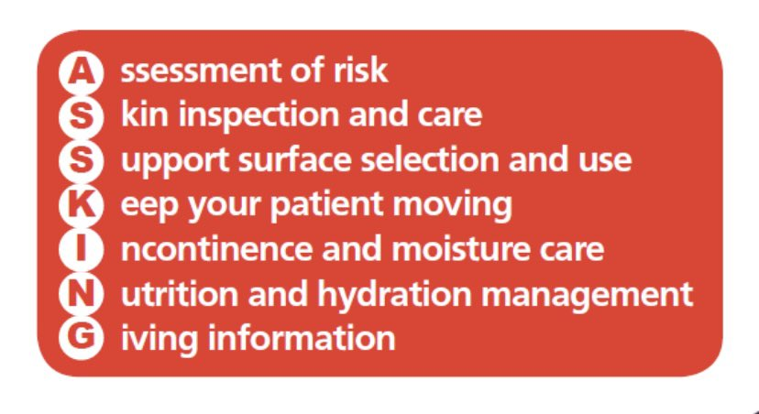

Pre-Competency knowledge
Skin Assessment

- An initial skin assessment should also be completed by the most senior person on duty at time of admission. On a nursing unit, this should be the Registered Nurse on duty. This should be recorded on a Skin Integrity Assessment (iCare Form – 1.04 Skin Integrity Assessment).
- CA’s should be aware of the outcome of this skin assessment, the condition of the clients skin and any concerns that it raised.
- Risk factors for changes to skin integrity-
  - Ageing, dry skin,
  - Sun damage
  - Irritants – dressings, tissue maceration from sweat, incontinence, saliva, wound fluid, high temperature, repeated skin cleansing, highly perfumed cleansers, polyester clothing, poor hygiene.
  - Infection – bacterial or fungal
  - Mechanical injury – scratching, skin tears, removal of adhesive tapes/dressings.
  - Immobility - pressure, friction, or shear forces.
  - Allergies
  - Medication

Moisture Associated Skin Damage (MASD) v Pressure Ulcers.
Pressure ulcers and Moisture lesions are often misdiagnosed. Therefore, it is important to understand and identify the difference between moisture damage and pressure ulcers.
Pressure damage occurs over any bony area of the body. The main areas of concern are notes on page 2 of this document. Pressure damage often appears to be regular in shape. You have to have a situation where there is unrelieved pressure over a bone that results in the tissue being squeezed until the blood stops flowing and it dies.

Moisture damage only happen when there is wetness that sits on the skin for long periods of time. It can vary in size, colour and shape and often appear as patches of sore skin which tend to occur in skin folds or on and between the buttocks. Moisture damage will not improve unless you address the source of the moisture. Moisture damage does not cause pressure ulcers.

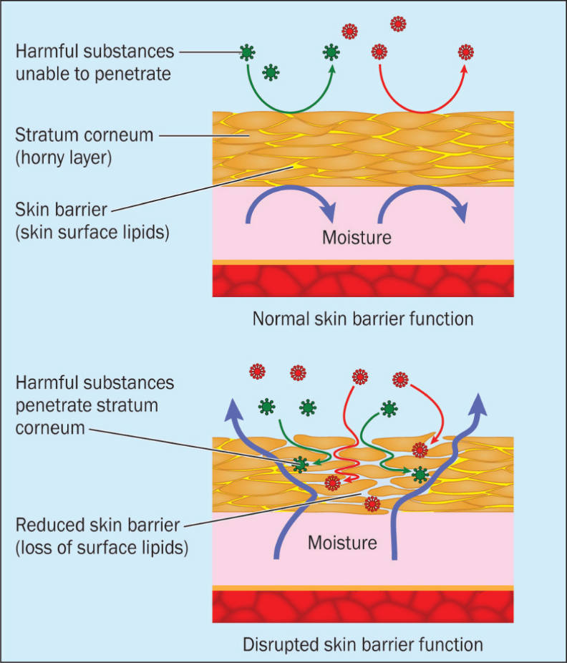
If the skin is exposed to too much moisture, it becomes overhydrated and is prone to maceration. This makes it easier for irritants and microorganisms to penetrate the skin, reduce its integrity to mechanical forces and disrupt its protective acid mantle. The condition can greatly affect patient wellbeing. Management of MASD involves assessment, prevention, addressing the underlying cause, and implementing a structured skin care regimen to treat it and prevent its recurrence.
- Incontinence-associated dermatitis (IAD) when the skin is exposed to urine, stool, or a combination of both. The skin becomes overhydrated causing the top layer of skin to crack and allow irritants to get under the surface of the skin. Skin becomes red, inflamed, and eventually breaks down.
- This can get worse by delay in cleaning after and episode of incontinence, incorrectly fitting or infrequent changing of continence garments/pads, blocking of pads with excessive cream/ ointment application or cleaning vulnerability skin with soap.
- Intertriginous Dermatitis (Intertrigo) – redness and skin breakdown in the skin folds ( arm pits, groin, tummy folds, neck folds, under breasts) from sweating, friction, poor hygiene, saliva, dribbling, non-breathable clothing (Young, 2017).

Care intervention.

- Patients at risk of developing IAD should have a daily skin inspection, or more frequently if they are at high risk of IAD. This can easily be incorporated into the routine skin inspection for pressure ulcer risk and patients’ hygiene needs (Voegeli, 2017).
- Any site identified to be at risk of prolonged exposure to moisture should be cleansed with a simple neutral pH skin cleanser (avoiding using soaps and perfumed products which strip natural oils from the skin) and using soft non-woven clothes rather than rough washcloths.
- Patting the skin dry avoiding additional friction damage from the act of rubbing the skin dry.
- For patients with occasional incontinence the use of simple moisturisers, after toileting, should be sufficient to replace the natural skin lipids and promote the natural skin barrier.
- For patient with more persistent incontinence, where the skin is showing signs of stress, then the use of skin barrier products is recommended. These can be in the form of creams or film products and should be applied sparingly and allowed to dry well before replacing pads or clothing. Application should follow the manufacturer’s instructions.
- The appropriate use of absorbent products is important, following an appropriate incontinence assessment, as they limit exposure to moisture and avoid overhydration of the skin. However, these need to be of highly breathable material with super absorbency which can control the pH level. If not, they may contribute to the worsening IAD by creating occlusive conditions alongside the possibility of prolonged exposure to urine and/or faeces due to infrequent pad changes or limited cleansing (Mugita, Y. et al. 2021).
- Consider the presence of fungal infection, especially in the folds of the groin area. This is characterised by a dry, pale-pink, or white area that causes an itchy or burning sensation. This can be treated with a topical anti-fungal cream, applied after washing and drying and before the application of moisturisers or barrier products. This should be applied regularly and until the symptoms subside. (Fletcher, J. 2020. Yates, A. 2020. Mehaffey, K. 2021)
- For patients suffering from Intertrigo consider the clothing – Patients should be encouraged to wear loose fitting, cotton, or natural fibre clothing, which is absorbent. Alternatively, there is a range of athletic clothing designed to wick away perspiration from the skin which may help. Avoid any synthetic fabrics.

Skin Protection

- It is important to be aware of the differences between and rational to use moisturisers or barrier products.
  - Moisturisers are intended to hydrate the skin, refresh the oily layer on the top of the skin, reduce skin dryness. It should be used as part of the patients every day skin care routine.
  - Barrier films are used to repel moisture and irritants from the surface of the skin so should only be used if moisture is the cause of the skin damage. They should never be used on pressure ulcers.

- For more information about moisture damage and lesions, please visit this following link: https://www.britishjournalofnursing.com/content/product-focus/moisture-associated-skin-damage-causes-and-an-overview-of-assessment-classification-and-management/

How can you tell if someone is at risk of developing a pressure ulcer?

- One of the first signs of a possible pressure sore is reddened skin, this could also be discoloured or appear as a darkened area. Please note, that darker skin tones may look or present as purple, bluish or shiny. The area may feel harder than usual and warm to the touch.

The below areas identified are areas of risk developing pressure ulcers:
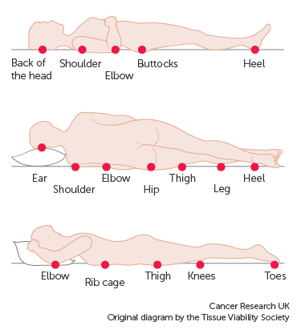

(Other areas to consider: Bridge of nose, ears, spine, back of knees, ankles, insides of ankles and toes, under splints, catheter bag ties, )

What are you looking and feeling for?
Clients with light or white skin tone.
- Redness/Erythema – non-blanching when blanch test completed.
- Pain, soreness, itching in the area.
- Warm or cool to touch over the bony prominence.
- Hardened area in comparison.
- Broken Skin / Ulcer.
Clients with darker skin tone.
- You cannot see redness on darker skin tones, so they are at a higher risk of going undetected and therefore becoming deeper pressure ulcers than those on light or white skin tones.
- Discolouration – dark red/purple/black – skin tone changes
- Hotter or colder than the patient’s normal skin
- Swelling or hardness
- Broken Skin / Ulcer.
Please note, any changes noted should be reported immediately to a RGN or SCA.

- A way of identifying a pressure ulcer, is if you remove pressure from the area of concern for 10 to 30 minutes and the skin does not return to its normal colour after that time. The resident must remain off of this area and findings reported immediately.
- Test the skin with a blanching test.
Conduct a blanching test by pressing on the red, pink or darkened area with your finger. The area should go white. Then remove the pressure, once removed the area should return to red, pink or darkened colour within a few seconds. This indicates a good blood flow.
If the area stays white, then blood flow has been impaired, and damage has begun. Action must be taken.
- Darker skin tones will not visible blanch even when healthy, therefore it is important to look for other signs of damage, such as colour changes or hardened skin, compared to surrounding areas.
- Warning: What is visible on the skin’s surface is often the smallest part of the pressure ulcer.
Skin damage caused by pressure doesn't start on the surface of the skin. Pressure usually results from the blood vessels being squeezed between the skin surface and bone, so the muscles and the tissues under the skin near the bone suffer the greatest damage.
- Every pressure ulcer seen on the skin, no matter how small, should be regarded as serious because of the probable damage below the skin surface.
Categories of pressure ulcers  (NWCSP 2023. NPIAP 2019) | Lighter skin tones | Darker skin tones
Category 1: Non blanchable erythema intact skin  In lighter skin tones, this presents as non-blanchable redness of a localised area usually over a bony prominence. Darkly pigmented skin may not have visible blanching, but its colour may differ from the surrounding area. The area may be painful, firm, soft, warmer, or cooler as compared to adjacent tissue. Category 1 may be difficult to detect in individuals with dark skin tones. May indicate “at risk” individuals (a heralding sign of risk). | 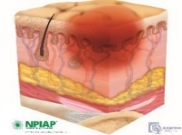 | 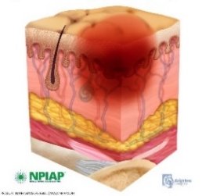 | 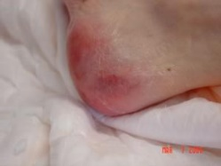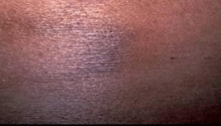
Category 2: Partial Thickness Skin Loss  Partial thickness loss of dermis presenting as a shallow open ulcer with a red/pink wound bed, without slough. May also present as an intact or open/ruptured serum-filled blister or as a shiny or dry shallow ulcer without slough or bruising*. This Category should not be used to describe skin tears, tape burns, perineal dermatitis, maceration, or excoriation. | 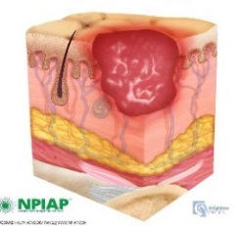 | 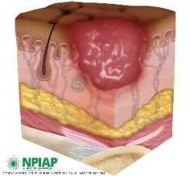 | 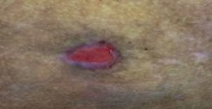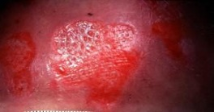
Category 3: Full Thickness Skin Loss  Full thickness tissue loss. Subcutaneous fat may be visible, but bone, tendon or muscle are not exposed. Slough or necrosis may be present. May include undermining and tunnelling. The depth of a Category 3 pressure ulcer varies by anatomical location. The bridge of the nose, ear, occiput, and malleolus do not have subcutaneous tissue and Category 3 ulcers can be shallow. In contrast, areas of significant adiposity can develop extremely deep Category 3 pressure ulcers. Bone/tendon is not visible or directly palpable. | 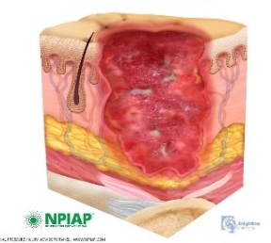 | 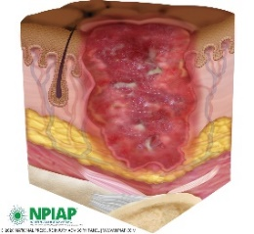 | 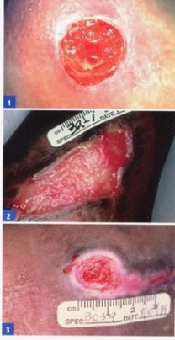
Category 4: Full Thickness Tissue Loss.  Full thickness tissue loss with exposed bone, tendon, or muscle. Slough or eschar may be present on some parts of the wound bed. Often includes undermining and tunnelling. The depth of a Category 4 pressure ulcer varies by anatomical location. The bridge of the nose, ear, occiput, and malleolus do not have subcutaneous tissue and these ulcers can be shallow. Category 4 ulcers can extend into muscle and/or supporting structures (e.g., fascia, tendon, or joint capsule) making osteomyelitis possible. Exposed bone/tendon is visible or directly palpable. | 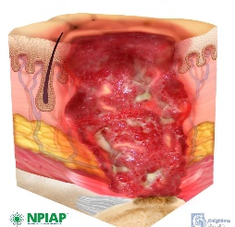 | 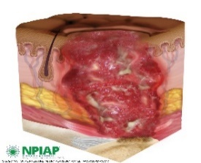 | 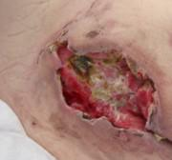  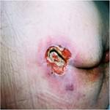
Pressure ulcers where the skin is broken but the wound bed is not visible due to slough or necrosis (formally referred to as ‘unstageable’) should initially be recorded as Category 3 pressure ulcers but immediately re-categorised and re-recorded in the patient’s records if debridement reveals Category 4 pressure ulceration. | 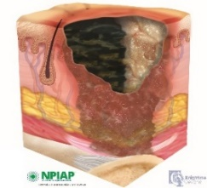 | 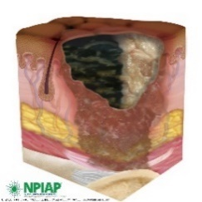 | 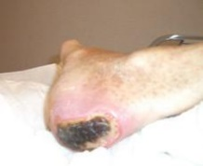  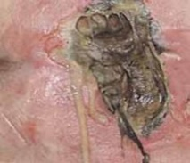
Changes from Feb 2024 – these may not have translated over to CQC so please follow your local policy.  Deep Tissue Injuries (DTIs) should not be reported as pressure ulcers unless they result in broken skin or they fail to resolve and it is evident on palpation there is deep tissue damage present, at which point, they should immediately be categorised and reported. However, the skin change must be recorded within the clinical record (for example by ticking the vulnerable skin option in the PURPOSE-T tool) and appropriate review schedule and preventative care delivered as soon as the damage is noted. |  |  | 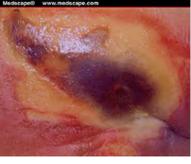  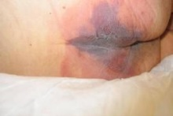

Please note, a STRICT repositioning chart should also be in place that evidence regular repositioning.

Competency

Competency & Awareness | Comments | Pass | Fail | HCA’s Signature | Assessor’s Signature
Maintaining SKIN Integrity

Discuss the importance of maintaining good skin integrity.

What factors could put a resident at greater risk of skin breakdown.
Identify which residents, within your care are at risk of damaged skin integrity.
Explain what moisturisers are used for, how often they should be applied and how much to apply?
Explain where, within the care plan, you can find the recommended skin care regime.
Preventing Pressure ulcers.

Explain how a pressure ulcer happens?
What areas of the body might you expect to see a pressure ulcer occurring?
How often should these areas be reviewed/checked
Describe how you would assess light or white skin tone residents pressure areas.
What are you looking for?
Describe how you would assess darker skin tone residents pressure areas.
What are you looking for?
What else might the resident be articulating that might indicate that their skin needs to be checked?
Discuss the signs a Category 1 Pressure Ulcer.
Discuss the signs of a Category 2 Pressure Ulcer.
Explain how pressure ulcers differ from moisture associated skin damage (MASD)
Explain how you would report any areas of redness or broken skin, and who you would report to.
Support Surface

Explain where, within the care records you can find which pressure relieving equipment and the setting the resident should be on.
Discuss where you would find the user guide for the equipment your residents are using?
Demonstrate an awareness of how and when to check that equipment is working correctly.
Explain what might make you suspect that a piece of equipment was not working properly?
Discuss the importance of ensuring that equipment is well maintained. (Decontamination, regular cleaning).
Explain where you would access the decontamination guidance and what products you would use.
Discuss the need for and how you would complete the monthly mattress audit.
Explain how you would report faulty equipment and to who.
KEEP MOVING

Identify which residents should be repositioned and often these residents need to be repositioned.
Explain why regular repositioning and/or position changes are important for our residents.
Discuss what you can encourage residents to do to help to maintain their mobility or change their own positions, both in bed and sitting out.
Explain which iCare chart should be used for documenting resident’s position changes.

Identify different techniques for repositioning a resident who is nursed in bed. (pillow/30degree tilt/slide sheet etc).
What changes would you need to report?
INCONTINENCE AND MOISTURE
Explain the damage that urine, faeces, sweat and wound exudate can cause on the skin.
Identify which residents, within your care are at risk of MASD.

List the areas on the body where you may find MASD.

Explain how you would report any areas of redness or broken skin, relating to MASD.
Explain the difference between a moisture lesion and a pressure ulcer.
Explain what the purpose of barrier products, how much you would apply, type and frequency.
Demonstrate an awareness of continence products and how these should be used to minimise moisture damage.
Explain the importance of promoting regular toileting.

Discuss the opportunities that arise, within your working day, that would allow you to check the condition of your resident’s skin?
What changes would you need to report?

NUTRITION AND HYDRATION

Discuss the importance of nutrition and hydration on maintaining good skin integrity and preventing pressure ulcers.
Explain the importance of keeping an accurate food chart for the first 72 hours after a resident is admitted.
Discuss why residents may be kept on a food and fluid chart after the first 72 hours.
Discuss what a ‘balanced diet’ might look like.
Explain how you can support residents to have access to adequate food and fluids.
Explain the importance of identifying residents with swallowing difficulties and how to find out what they can eat and drink.
Explain the importance of keeping a strict and accurate food record (food chart on iCare).
Describe the importance of a fortified diet and the use of supplements for those who are at risk.
Explain who you would report nutritional concerns to.

Competency Complete.

