Clinical Skills Competency Assessment

ASSKING and Pressure Damage
Registered Nurse Name:
Registered Nurse Signature:
Assessor Name:
Assessor Signature:
Pass / Fail

Date Competency completed:

WE STATEMENT

We focus on continuous learning, innovation and improvement across our organisation and the local system. We encourage creative ways of delivering equality of experience, outcome and quality of life for people. We actively contribute to safe, effective practice and research.

INTRODUCTION

The ASSKING competency has been designed to assess staff awareness, effectiveness of care planning and clinical judgement for residents who may be deemed to be risk of pressure damage.

The objective of this competency is to highlight the importance of all factors that are involved in maintaining skin integrity for a resident who is at risk of pressure damage. It also helps to identify the importance of accurate record keeping and effective care planning in relation to ASSKING.

At Elizabeth Finn Homes Limited we aim to avoid pressure injury/damage occurring at all. However, where pressure damage may be identified we look to recognise this early, in order to prevent further deterioration and promote positive healing.

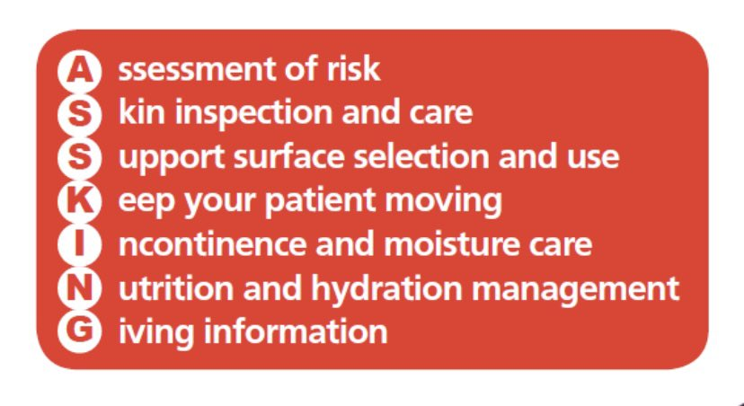

Pre-Competency knowledge
Risk Assessment

- All residents will be assessed, within 6 hours of admission, using the Waterlow Screening tool (iCare Form - 1.03 Waterlow Pressure Ulcer Assessment).
- Waterlow Assessment should be completed at least once per month, per resident. If there is a concern that a resident is at risk, this may assessment may be used more frequently.
- The Waterlow Assessment should be used in addition of the Registered Nurses Clinical Judgement, not in place of.
- A Waterlow Assessment score of 10 or above, indicates there is risk of pressure damage and clinical intervention is required.
- An initial skin assessment should also be completed by the most senior person on duty at time of admission. On a nursing unit, this should be the Registered Nurse on duty. This should be recorded on a Skin Integrity Assessment (iCare Form – 1.04 Skin Integrity Assessment).

The below areas identified are areas of risk:
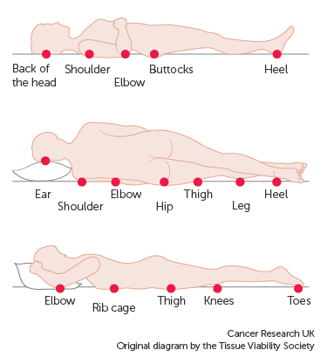

(Other areas to consider: Bridge of nose, spine, back of knees, ankles, insides of ankles and toes)

What are you looking and feeling for?

- Redness/Erythema – non-blanching when blanch test completed.
- Pain and Soreness on the area.
- Warm or cool to touch over the bony prominence.
- Hardened area in comparison.
- Discolouration – dark red/purple/black.
- Broken Skin / Ulcer.

Please note, any changes noted should be documented on form 1.03 Waterlow Pressure Ulcer Assessment and 1.04 Skin Integrity Assessment.

How can you tell if someone has a pressure ulcer?

- One of the first signs of a possible pressure sore is reddened skin, this could also be discoloured or appear as a darkened area. Please note, that darker skin tones may look or present as purple, bluish or shiny. The area may feel harder than usual and warm to the touch.
- A way of identifying a pressure sore, is if you remove pressure from the area of concern for 10 to 30 minutes and the skin does not return to its normal colour after that time. The resident must remain off of this area and find and correct the cause immediately. (Review pressure relieving equipment at this time).
- Test the skin with a blanching test.
Conduct a blanching test by pressing on the red, pink or darkened area with your finger. The area should go white. Then remove the pressure, once removed the area should return to red, pink or darkened colour within a few seconds. This indicates a good blood flow.
If the area stays white, then blood flow has been impaired and damage has begun. Action must be taken.
- Darker skin tones may not have visible blanching even when healthy, therefore it is important to look for other signs of damage, such as colour changes or hardened skin, compared to surrounding areas.
- Warning: What is visible on the skin’s surface is often the smallest part of the sore.
Skin damage caused by pressure doesn't start on the surface of the skin. Pressure usually results from the blood vessels being squeezed between the skin surface and bone, so the muscles and the tissues under the skin near the bone suffer the greatest damage.
- Every pressure sore seen on the skin, no matter how small, should be regarded as serious because of the probable damage below the skin surface.

Pressure Sore Categories

Category 1 Pressure Ulcer
Skin is not broken but is red or discoloured. It is intact skin non-blanching redness.

When you press on it, it stays red and does not lighten or turn white (blanch). The redness or change in colour does not fade within 30 minutes after pressure is removed.

It may show changes temperature compared to surrounding areas: This includes being either hotter or cooler to touch.

The area may be painful to touch; the resident may require increased amounts of analgesia to help manage discomfort.

Stage 1 may be more difficult to detect in residents with darker skin tones. Darker pigmented skin may not have visible blanching; its colour may differ from the surrounding areas.
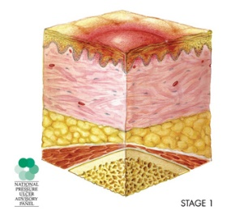
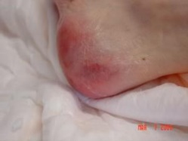

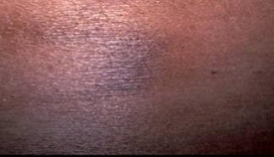

Category 2 Pressure Ulcer

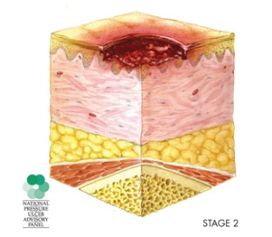
Partial thickness loss of dermis, presenting in a shallow open ulcer, with a red / pink wound bed.

There may be exudate or fluid leakage may or may not be present.

It may present as an open / ruptured blister or a shiny dry ulcer, without slough or bruising.

This stage should not be used to describe skin tears, tape burns, perineal dermatitis, maceration or excoriation.

Bruising indicates a deep tissue injury.

If developing a stage 2 sore within the organisation, or admitted with a stage 2 sore an EFHL benchmark safeguarding referral is required.

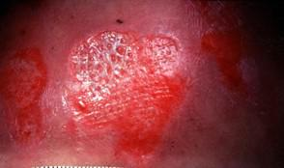

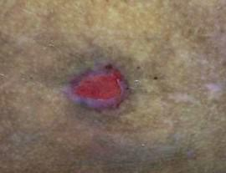

Category 3 Pressure Ulcer
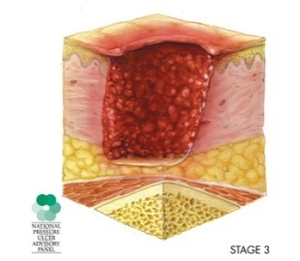
The wound extends through the dermis (second layer of skin) into the fatty subcutaneous (below the skin) tissue. Full tissue thickness loss.

Subcutaneous fat may be visible, but bone, tendon and muscle are not exposed. The depth of a Stage 3 pressure ulcer varies by the anatomical location (the bridge of the nose, ear, occiput and malleolus does not have subcutaneous tissue).

Slough may be present at this stage, but would not obscure the depth of tissue loss. This stage may include tunnelling or undermining.

There is a possibility of infection at this stage (there may be redness around the edge of the sore, increased exudate, coloured exudate and increased odour. The resident’s body temperature may be increased too).

If admitted with a stage 3 sore, safeguarding referral is required.

Stage 3 is CQC notifiable.
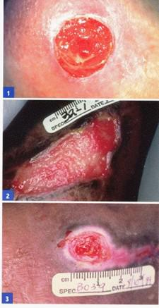

Category 4 Pressure Ulcer
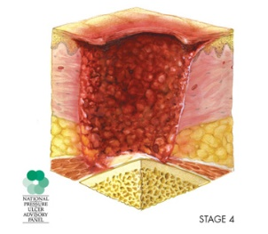
The wound extends into the muscle and can extend as far down as the bone.
The depth of a Stage 3 pressure ulcer varies by the anatomical location (the bridge of the nose, ear, occiput and malleolus does not have subcutaneous tissue).

There is usually lots of dead tissue and drainage are present. Exposed bone / tendon is visible or directly palpable.

Slough or eschar may be present on some parts of the wound bed. This stage often includes tunnelling or undermining,

There is a high possibility of infection at this stage.

If admitted with a stage 4 sore, safeguarding referral is required.

Stage 4 is CQC notifiable.

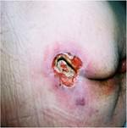

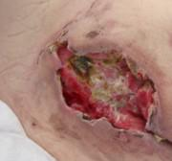

Unstageable Pressure Ulcer
Full thickness loss, whereby the full base of the ulcer is covered with slough or eschar. The slough may be yellow, grey, tan, green, or brown in the wound bed, the eschar may be tan, black or brown.

Until enough slough or eschar has been removed to see the base of the ulcer, the true depth and therefore stage of the ulcer cannot be determined.

The wound is usually stable (dry, adherent and intact without erythema or fluctuance).

Eschar on the heel acts as “the bodies natural biological cover” and therefore should not be removed.

There is a possibility of infection at this stage.

If admitted with an unstageable pressure ulcer, safeguarding referral is required.

Unstageable pressure ulcers are CQC notifiable.

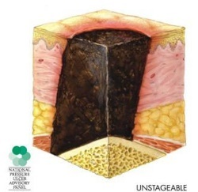
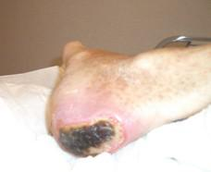

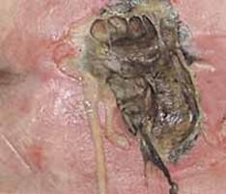

Suspected Deep
Tissue Injury
This may present as a purple or maroon localised area of discoloured intact skin or blood-filled blister. Due to damage of underlying soft tissue pressure and/or shear.

The area may be proceeded by tissue that is painful, firm, mushy, boggy, warmer or cooler to touch, compared to adjacent tissue.

Deep tissue injuries may be harder to detect in residents with darker skin tones. Evolution may include a thinner blister over a dark wound bed.

Evolution may be rapid, exposing additional layers of tissue as it breaks down - even with optimal treatment.

If admitted with a suspected deep tissue injury, safeguarding referral is required.

Suspected deep tissue injuries are CQC notifiable.

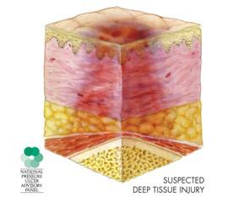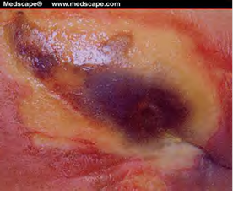
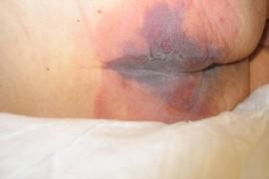

Definitions

Eschar

A wound covered with thick, dry, black necrotic tissue.
Eschar may be allowed to slough of naturally, or it may require surgical removal.
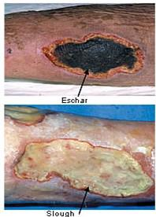
Slough

A mass, or layer of dead tissue, separating itself from the surrounding or underlying tissue.
This is usually cream or yellow in colour.
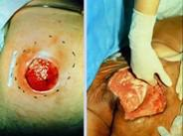
Undermining

The wound extends under visible opening.
A hollow between the skin surface and the wound bed, that can occur when necrosis destroys the underlying tissue.

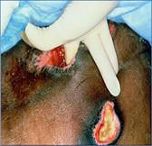
Tunnelling

A Narrow opening or passage way underneath the skin that can spread in any direction, through soft tissue. This can result in dead space for potential of abscesses to form.

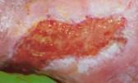
Maceration

The softening and eventual breakdown of tissue due to excess moisture – making the would prone to infection.

Pressure Sore Vs Moisture Lesion

Pressure ulcers and Moisture lesions are often misdiagnosed. Therefore, it is important to understand and identify the difference between a pressure sore and a moisture lesion.

Pressure damage occurs over any bony area of the body. The main areas of concern are notes on page 2 of this document. Pressure damage often appears to be regular in shape.

Moisture lesions can vary in size, colour and shape and often appear as patches of sore skin which tend to occur in skin folds or on and between the buttocks.

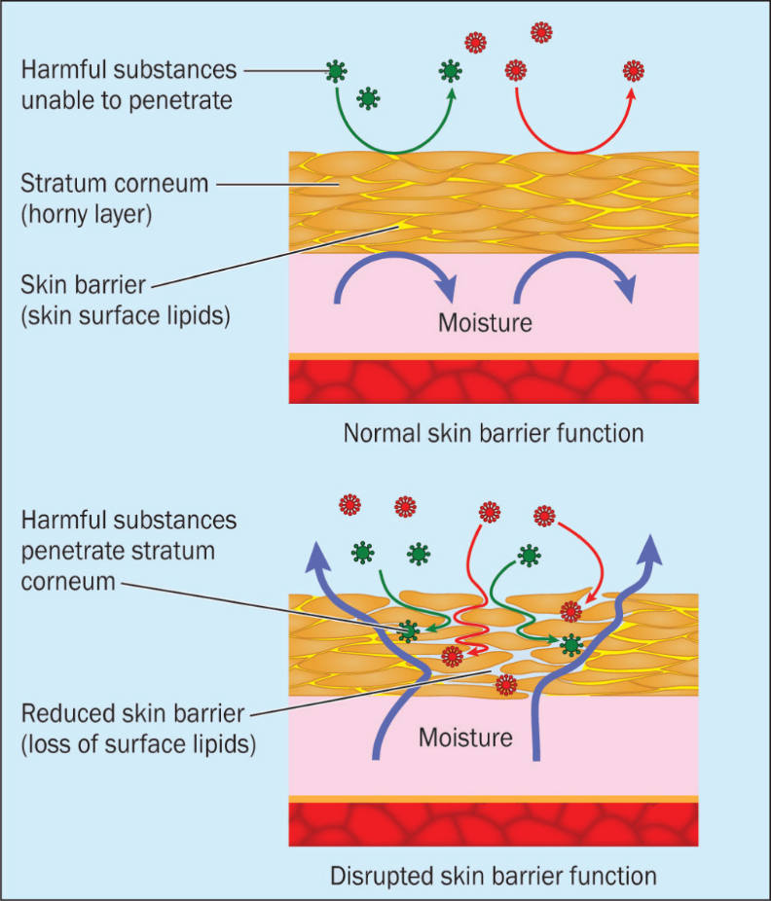
Moisture-associated skin damage (MASD) can result when the skin has prolonged or continuous exposure to excessive moisture.
If the skin experiences too much moisture, it becomes overhydrated and is prone to maceration. This makes it easier for irritants and microorganisms to penetrate the skin, reduce its integrity to mechanical forces and disrupt its protective acid mantle. The condition can greatly affect patient wellbeing. Management of MASD involves assessment, addressing the underlying cause, and implementing a structured skin care regimen to treat it and prevent its recurrence. Case studies illustrate the use of a structured treatment strategy using Medi Derma barrier products and the principles of Total Barrier Protection to provide a cost-effective solution for the prevention and management of skin compromised by MASD.

For more information about moisture damage and lesions, please visit this following link: https://www.britishjournalofnursing.com/content/product-focus/moisture-associated-skin-damage-causes-and-an-overview-of-assessment-classification-and-management/
Documentation around Pressure Damage

If a resident has a pressure ulcer, the following should be documented on form 1.03 Waterlow Pressure Ulcer Assessment and form 1.04 Skin Integrity Assessment:

- Waterlow Score – this should be updated upon each assessment.
- Nutritional requirements.
- Continence needs/requirement.
- Grade and location of the pressure sore.
- Origin of the pressure sore – was this acquired in or outside of the facility.
- Pressure relieving equipment in place – be specific with brands, sizes and settings.
- Dressings used and in place – this should also be recorded on the Wound Chart and form 5.06 Wound Treatment Care Plan.
- Residents involvement/communication and their wishes and any verbal advice given.

Other documentation required for a resident who has a pressure ulcer:

- MUST score to be completed monthly. If a resident is At Risk, this should be completed weekly, along with the weekly weight. Dietician referral should be made at this point.
- Photograph should be taken and recorded at EVER dressing change. If there is no dressing in place, a minimum of three times per week.
- Communication with family / NOK – this should be recorded on Form 4.03 Family/Relatives Communication.
- If the resident lacks capacity, best interest should be sought.

If the Pressure ulcer is at Category 3 or 4, the following should also be considered:

- Safeguarding referral required. Regional Manager and Clinical Director should receive a copy of this.
- CQC notification to be submitted at this time. Regional Manager and Clinical Director to receive a copy of this.
- Tissue Viability input will be required – Internal Tissue Viability Champion or Local Tissue Viability Nurse Specialist should be involved in ensuring that appropriate treatment is in place.
- If the pressure sore is located on the lower limbs, a Doppler assessment will be required to establish the need for debridement.

Please note, a STRICT repositioning chart should also be in place that evidences regular repositioning.

Factors That Can Affect Healing
- Age
- Reduced amount of oxygen to the wound.
- There is a slower turnover rate in the epidermal cells.
- Reduced dermal and subcutaneous mass.
- Altered / Reduced nutritional intake.
- Impaired function of the vital organs; including immune or respiratory systems.
- Increased amount of diagnosed chronic health conditions.
- Healed wounds lack tensile strength and therefore are more likely to reinjury.
- Medications
- Any medications that reduces a resident’s movement, circulation and / or metabolic functions: such as Sedatives.
- Any medications that reduces a resident’s ability to mount an appropriate inflammatory response: such as Steroids.
- Nutrition and hydration
- Malnutrition increases the risk of developing a pressure ulcer and delays healing.
- Protein in crucial in the proper healing of a pressure ulcer.
- The intake of Vitamins C, B-Complex, A and E and Minerals Iron, Copper, Zinc and Calcium and critical in the proper healing of a pressure ulcer.
- Oxygenation
- Wound healing relies on a regular supply of oxygen in the body. This is critical for leukocytes to kill bacteria.
- The lack of oxygen in the body can cause inadequate blow flow to the pressure ulcer.
- Infection
- Recognising early signs of infection is critical: New or increased pain, exudate, redness to the surrounding area, heat, temperate and malodour.
- Systemic infections, such as pneumonia increase metabolism and deflates fluids, nutrients and oxygen – all of which are needed to help heal pressure ulcers.
- Chronic Health Conditions
- Pulmonary disease, atherosclerosis and diabetes (for example) increase risk or pressure damage and can delay the wound healing.
- Neuropathy, associates with diabetes can increase the risk of pressure damage and can impair leukocyte function within the body.
- Impaired circulation is also a contributing factor to the delay in a wound healing.
- Chronic conditions to be mindful of: End Stage Kidney Disease, Thyroid Disease, Heart Failure, Peripheral Vascular Disease, Vasculitis, and other collagen vascular disorders.
- Smoking
- Cardon Dioxide affects the haemoglobin in the blood.
- It can reduce the amount of oxygen circulating the body.
- Nicotine can cause vasoconstriction and an increased coagulability.

Competency

Competency & Awareness | Comments | Pass | Fail | RN Signature | Assessor’s Signature
SURFACE

Identify which residents, within your care are at risk of pressure damage.

Identify the importance of recording accurate Waterlow assessments and how often these should be reviewed.
Explain what pressure relieving equipment should be available for those residents who are scoring 10-14 (At Risk).
Explain what pressure relieving equipment should be available for those scoring 15-19 (High Risk) on the Waterlow assessment.
Explain what pressure relieving equipment should be available for those scoring 20+ (Very High Risk) on the Waterlow Assessment.
Evidence where, within the care plan pressure relieving equipment and the setting used, should be recorded.
Demonstrate an awareness of how and when to check that equipment is working correctly.

Discuss the importance of ensuring hat equipment is well maintained. (Decontamination, regular cleaning and annual mattress/cushion audit).
Discuss the need and importance of completing the monthly mattress audit.

Explain how you would report faulty equipment and to who.

Identify how often an external agency (such as pressure care direct) should conduct a fit for purpose assessment of all pressure relieving equipment.
SKIN INSPECTION

Identify the different factors that can affect the healing of wounds / pressure ulcers and moisture lesions.
Identify pressure areas to asses and how often these areas should be reviewed/checked.

Describe how you would conduct a blanch test to assess the pressure area.

Explain how you would report any areas of redness or broken skin, and who you would report to.
Explain how you would identify areas for concern if those with a darker skin tone.

Explain where to document concerns around pressure area care (wound charts / wound treatment care plan).
Explain why it is important to take a photograph on each review.

Identify preventative measures that will need to be implemented, if not already in place.
Identify early signs of pressure damage and how you would diagnose a Category 1 Pressure Ulcer.
Identify and explain how and what factors would lead you to diagnose a Category 2 Pressure Ulcer.
Identify and explain how, and what factors would lead you to diagnose a Category 3 Pressure Ulcer.
Identify and explain how, and what factors would lead you to diagnose a Category 4 Pressure Ulcer.
Identify and explain how a wound would present if it was diagnosed as Unstageable.

Identify and explain how a wound would present if it was diagnosed as a Suspected deep Tissue Injury.
KEEP MOVING

Identify which residents should be repositioned and often these residents need to be repositioned.
Explain why regular repositioning and/or position changes are important for our residents.
Explain which iCare chart should be used for documenting resident’s position changes.

Identify different techniques for repositioning a resident who is nursed in bed. (pillow/30degree tilt/slide sheet etc).
Identify different techniques for protecting pressure areas that could be as a result of glasses/oxygen tubing. (Aderma Dermal Pads etc).
INCONTINENCE AND MOISTURE
Explain the damage that urine, faeces, sweat and wound exudate can cause on the skin.

Explain how you may prevent moisture damage.

Explain the difference between a moisture lesion and a pressure ulcer.

Identify the difference between different barrier products that are available on the local formulary.
Explain how you would use a barrier product and when it would be used.

Demonstrate an awareness of continence products and how these should be used to minimise moisture damage.
Explain the importance of promoting regular toileting and how you would ensure care staff complete this on shift.
NUTRITION AND HYDRATION

Explain why a healthy, well balanced diet is critical in pressure area prevention.

Identify which residents are at risk of pressure damage due to being underweight.

Identify which residents are at risk of pressure damage due to being overweight.

Explain the importance of keeping a strict and accurate food record (food chart on iCare).
Describe the importance of a fortified diet and the use of supplements for those who are at risk.
Explain how to report nutritional concerns and who you would report to.

Competency Complete.

